
Table of Contents
Introduction 3
Assumptions used in the ERD design 3
Er Diagram 6
Data Dictionary 7
SQL Functionality for Data Integrity 12
Test and Evidence 13
Below is the test plan I created. 13
Screenshot Evidence 14
Error Checking and Validation in Stored Procedures 17
Security Management 20
User role testing summary 20
Screenshots Evidence 20
Security Management Discussion 24
References 26

Part A

Introduction
Tony's Toy Emporium TTE Ltd started out as a tiny shop in a market town but now they're selling toys and video games all over the country. Even though the business has grown a lot they're still doing everything on paper customer information, sales, inventory. So that paper trail slows things down during normal working time. Staff have to search through paperwork to discover details and mistakes or duplicate entries are common. Even the checking of stock/pulling reports for management takes way longer than it should.
Due to all these problems the company's is looking to migrate its records into a database. By doing this we can store all the info in one system instead of having to deal with separate paper files. It should also make it easier to keep track of inventory when items move from one place to the next especially important when you've got a number of stores involved. So in this way staff will be able to log purchases much faster and to check what products are available in the stores or warehouses.
In this assignment I have designed a relational database with PostgreSQL. I included ER Diagram and Data dictionary with everything normalized to Third Normal Form. I wrote SQL scripts to create the tables and put some sample data into the tables. I also put a few stored procedures to handle things such as registering customers, recording purchases and generating management reports.

Assumptions used in the ERD design
Bank – Customer
Each customer must provide bank details for payment purposes, including the bank name, sort code and account number. Therefore, each customer is associated with exactly one bank. A bank may be associated with many customers.
Customer – Purchase
A customer may exist in the system without making any purchases. However, every purchase must be made by exactly one customer so that the organisation can identify who made the purchase.

Purchase – Store
Each purchase must occur at exactly one store. A store may record many purchases, although it is possible for a store to exist in the system before any purchases are recorded.

Purchase – Purchase_Item
A purchase may contain one or many purchase items because a customer may buy multiple products in a single transaction. Each purchase item belongs to exactly one purchase.

Purchase_Item – Product
Each purchase item refers to exactly one product. A product may appear in many purchase items or may not appear in any purchase items if it has not yet been sold.

Product – Stock
A product may be stored in many stock records or may have no stock if it has not yet been distributed. Each stock record must correspond to exactly one product. Each stock record represents the quantity of a product stored at a specific location such as a store or a warehouse.

Stock – Store
Each stock record may represent the quantity of a product stored at a store. A store may contain many stock records because it can hold many different products. It is also possible for a store to exist without holding any stock.

Stock – Warehouse
Each stock record may also represent the quantity of a product stored in a warehouse. A warehouse may contain many stock records because it can store many different products. A warehouse may exist in the system even if it currently has no stock records.

Warehouse – Stock_Transfer
A warehouse may exist in the system even if no stock transfers have yet occurred. Therefore, a warehouse can send zero or many stock transfers, but each stock transfer must originate from exactly one warehouse.

Store – Stock_Transfer
The association between Store and Stock_Transfer is considered a dual-role relationship to facilitate the movement of stock between stores.
Sends
A stock transfer can be done through a store. A store can send none or numerous transfers. But all transfers that are made out of a store must be made out of a single store.
Receives
The receiving location can also be a store. A warehouse or another store can send zero or numerous transfers to a store. so each transfer has to be sent to a single store. The source of each transfer should be clearly identified and can be a Warehouse or a Store.
Stock_Transfer – Transfer_Item
A stock transfer may include several transfer items because multiple products may be moved in a single transfer. Each transfer item belongs to exactly one stock transfer.

Transfer_Item – Product
Each transfer item refers to exactly one product being transferred. A product may appear in many transfer items or may not appear in any transfer if it has never been moved between locations.

Er Diagram
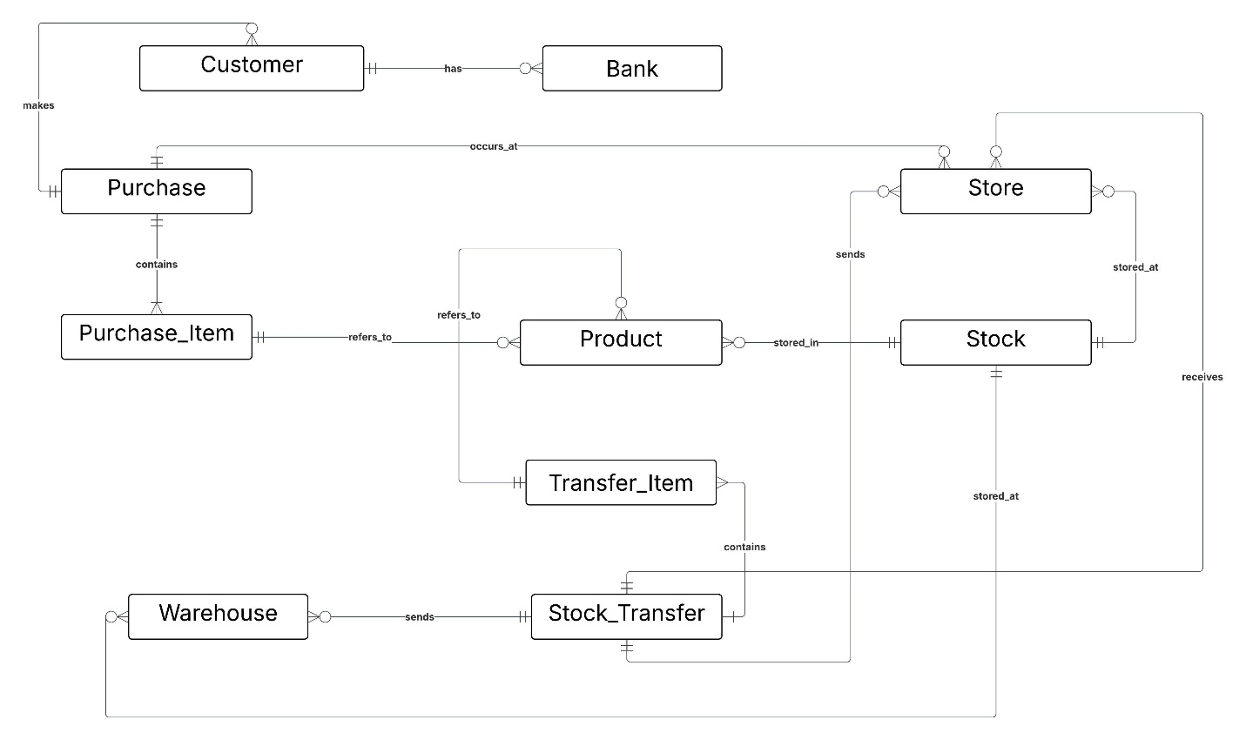

Data Dictionary
Bank
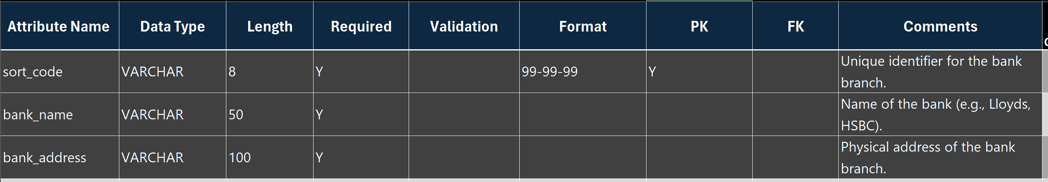
Functional Dependencies: The sort_code → (the bank_name and bank_address).
3NF statement
The primary key here was the sort_code because it is unique to each branch. The primary reason why I extracted this data into its own table was to prevent the repetition of the address in the Customer table. The transitive dependency is resolved by the fact that the address is based solely on the Sort Code and not the customer moving it here puts the address in 3NF.
Customer
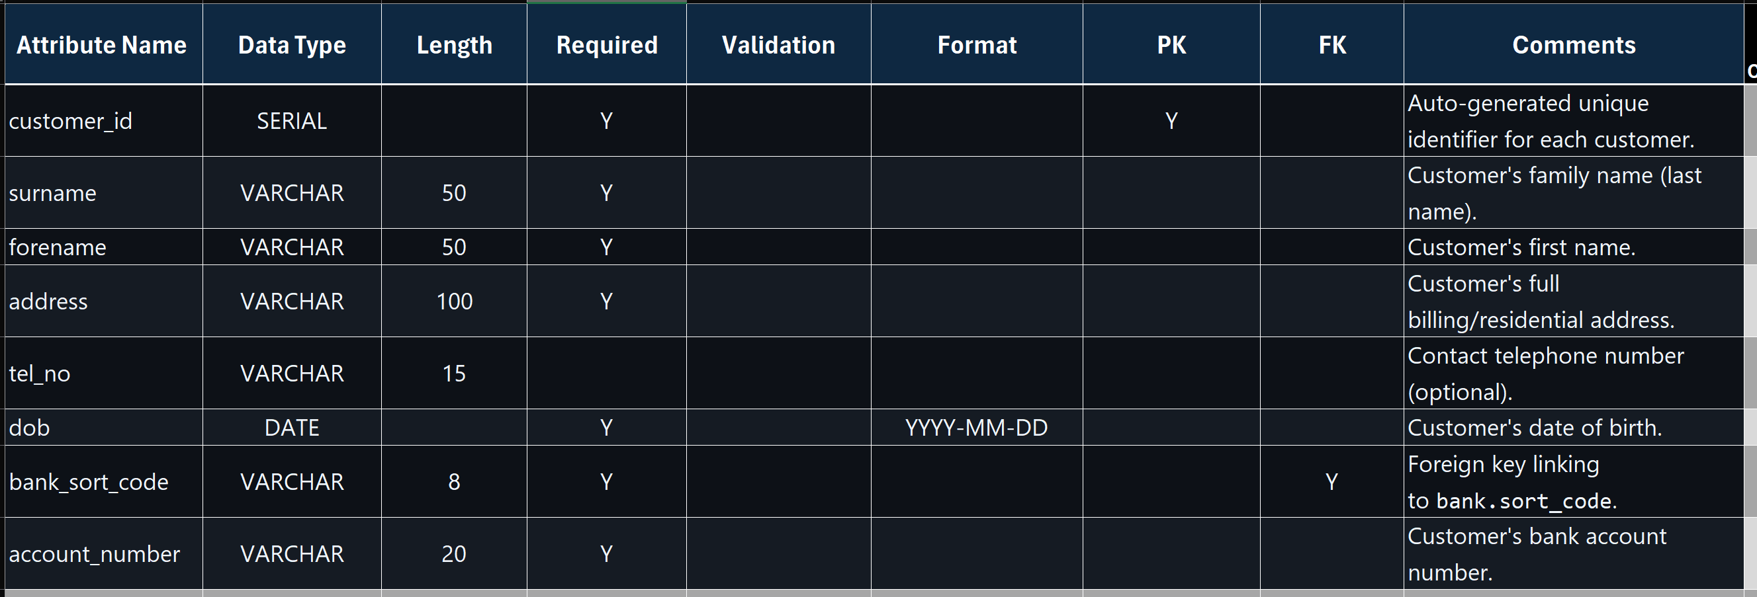

Functional Dependencies: `customer_id` → (`surname`, `forename`, `address`, `dob`, `tel_no`, `bank_sort_code`, `account_number`)
3NF Statement
I took customer_id as the primary key to identify each customer uniquely. The rest of the attributes such as surname, forename, address, tel_no, dob, bank sort code and account number are all dependent on this key since they are used to describe that particular customer. When I delete the customer id, I will not be able to identify or determine any of these values, which demonstrates complete dependency. I also ensured that the non key attributes do not depend on one another, such as the name of a customer does not define his or her address or phone number. Thus, there are no transitive dependencies, and the table is in the Third Normal Form 3NF.
Store
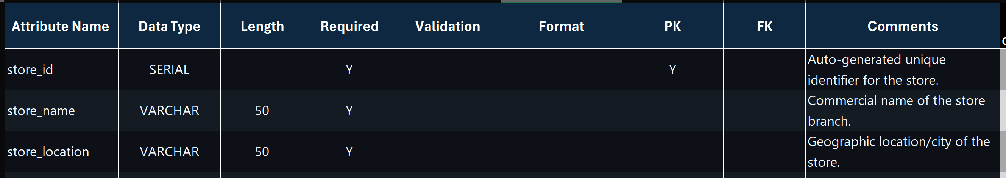
Functional Dependencies: `store_id` → (`store_name`, `store_location`)
3NF Statement
The table meets 3NF, as all the non-key attributes (store_name, location) can be reduced to the primary key store_id and they have no partial or transitive dependencies. store_id is a super key due to its uniqueness to each row and defining all the other attributes. As all functional dependencies have a super key on the left-hand side, the table is in Third Normal Form 3NF.

Warehouse
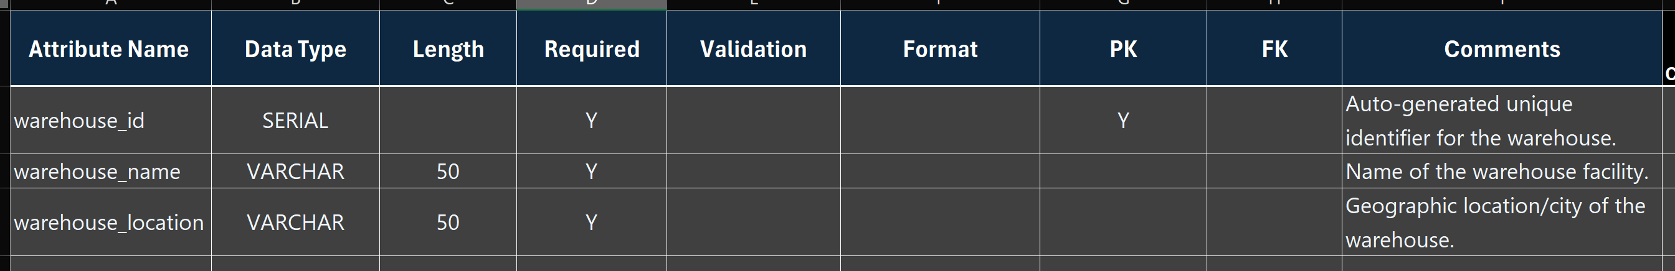
Functional Dependencies: `warehouse_id` → (`warehouse_name`, `warehouse_location`)
3NF Statement:
Same logic as the Store table essentially. The warehouse_id is the only key, and the other columns just describe that specific warehouse. No repeating groups, no partial dependencies—it's clean.

Product
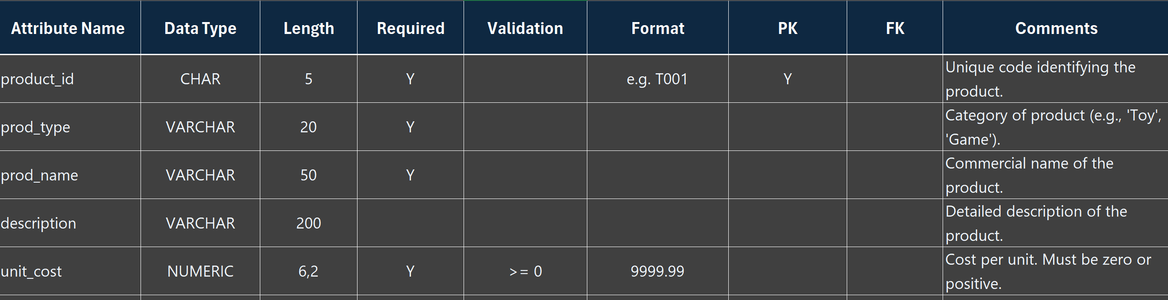
Functional Dependencies: `product_id` →( `prod_type`, `prod_name`, `description`, `unit_cost`)
3NF Statement
The table takes product_id as a primary key a single attribute. Since the primary is not a composite key, then partial dependencies can never be the case so the table is automatically in Second Normal Form 2NF. Moreover, the remaining non key attributes ( prod_type, prod_name, description and unit_cost) are totally functionally dependent on the primary key. Among these non key attributes there are no transitive dependencies. An example is that the product type prod_type does not have a functional role in determining the name of the product prod_name or its distinct cost unit_cost. As a result due to the strict dependence of all the non-key attributes by the primary key and not depending on another non key attribute, the table completely satisfies the Third Normal Form 3NF.
Stock
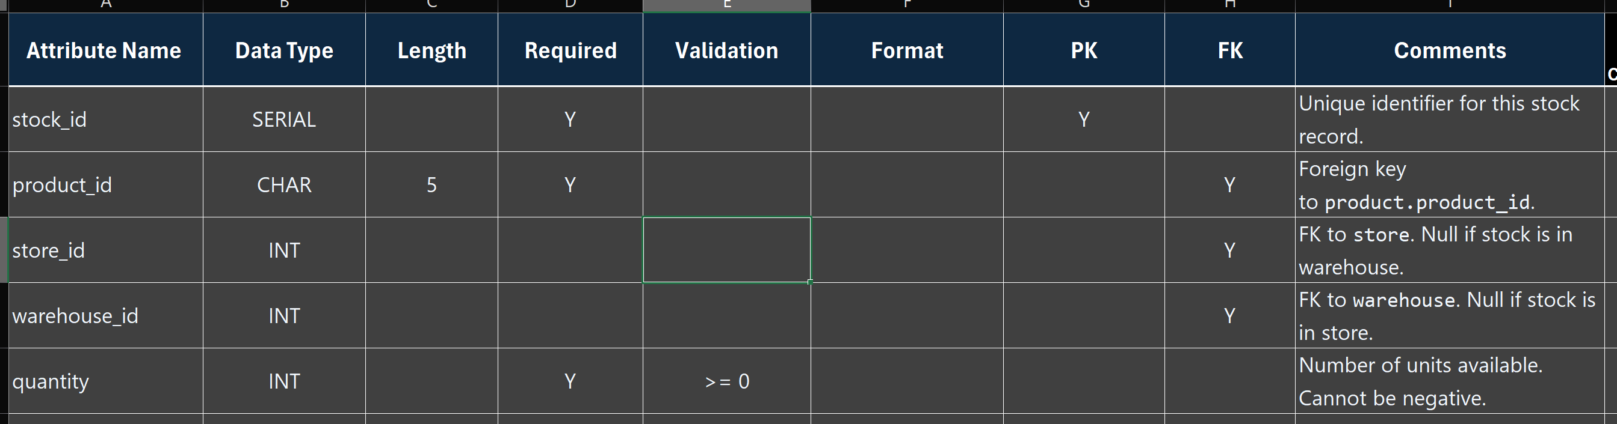
Functional Dependencies: `stock_id` → (`quantity`, `product_id`, `store_id`, `warehouse_id`)
3NF Statement
I created this table to separate the inventory count from the product details. The `quantity` here depends on the specific stock record which links a product to a place. If I had put quantity inside the Product table it wouldn't have worked because one product can be in many places. This structure keeps it normalized.

Purchase
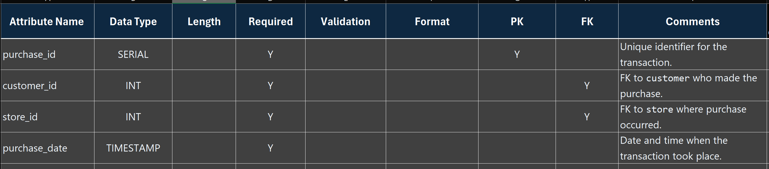
Functional Dependencies: `purchase_id` → (`customer_id`, `store_id`, `purchase_date`, `total_amount`)
3NF Statement
I took purchase_id as the primary key to identify every purchase. It is dependent on all the attributes customer_id, store_id, purchase date since without the key, the values cannot be established. So these attributes are not dependent on one another and hence no transitive dependencies. Thus, the table is in the Third Normal Form 3NF.
Purchase_Item
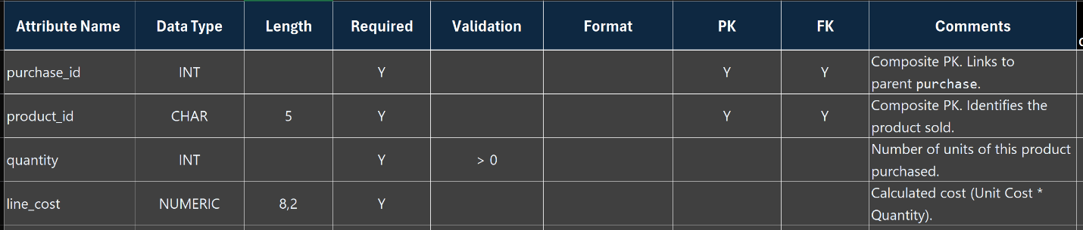
Functional Dependencies: `purchase_id` + `product_id` → (`quantity`, `line_cost`)
3NF Statement
This one needed a Composite Primary Key. The quantity sold depends on both the purchase_id and the product_id combined. You can't just use one ID to find the quantity. Since the non-key attributes rely on the whole key, it passes the 2NF and 3NF checks.

Stock_Transfer
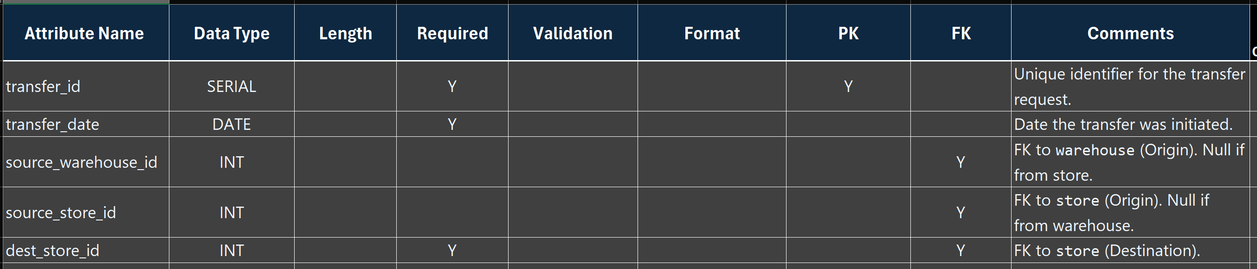
Functional Dependencies: `transfer_id` → (`transfer_date`, `source_warehouse_id`, `source_store_id`, `dest_store_id`)
3NF Statement
The primary key is transfer_id, which uniquely identifies each transfer. The rest of the non-key attributes transfer_date, source_warehouse_id, source_store_id, dest_store_id are completely functionally dependent on this key. The foreign keys are referenced to other tables but are not dependent on each other, thus eliminating any transitive dependencies. As a result the table is in Third Normal Form 3NF.
Transfer_Item
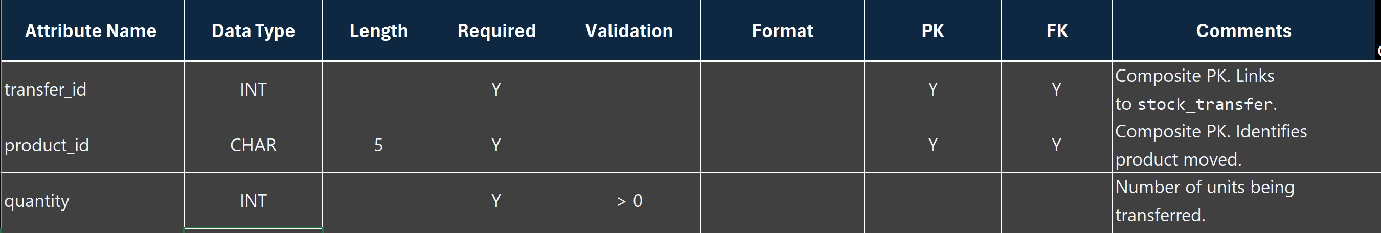
Functional Dependencies: `transfer_id` + `product_id`, → (`quantity `)
3NF Statement
The table uses a composite key of transfer_id and product_id to identify each record uniquely, thus making sure that no product is represented more than once in a transfer. The quantity attribute is functionally dependent on the joint combination of transfer id and product id; the elimination of either of the two elements makes the quantity indeterminate, thus making it fully dependent and meeting the requirements of the second normal form. There is no situation where the amount is determined by any non-key attribute, and thus there is no transitive dependency. As a result, the table becomes compliant with the third normal form.

SQL Functionality for Data Integrity
I applied different SQL features to maintain data integrity and avoid invalid data entry. Each table was given a PRIMARY KEY, most of which were SERIAL which is used to create unique identifiers automatically. The referential integrity and orphan records were maintained by the use of FOREIGN KEY constraints. NOT NULL constraints are used to make sure that mandatory fields are not left empty. Also, CHECK constraints were used to enforce valid data values, e.g. negative stock levels or invalid dates. These constraints provide consistency and reliability of data throughout the database.

Test and Evidence

Below is the test plan I created.
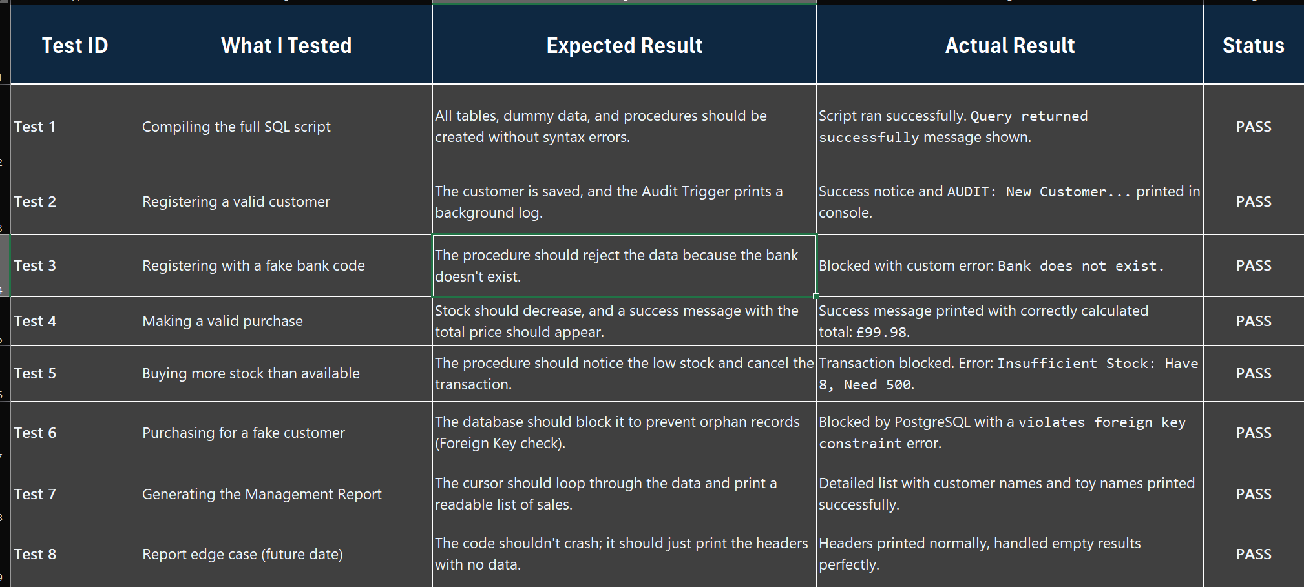

Although the initial sample data is limited, more records are created during testing using the stored procedures. This assists in simulating the actual use of the system and makes sure that all the tables contain sufficient data.

Screenshot Evidence
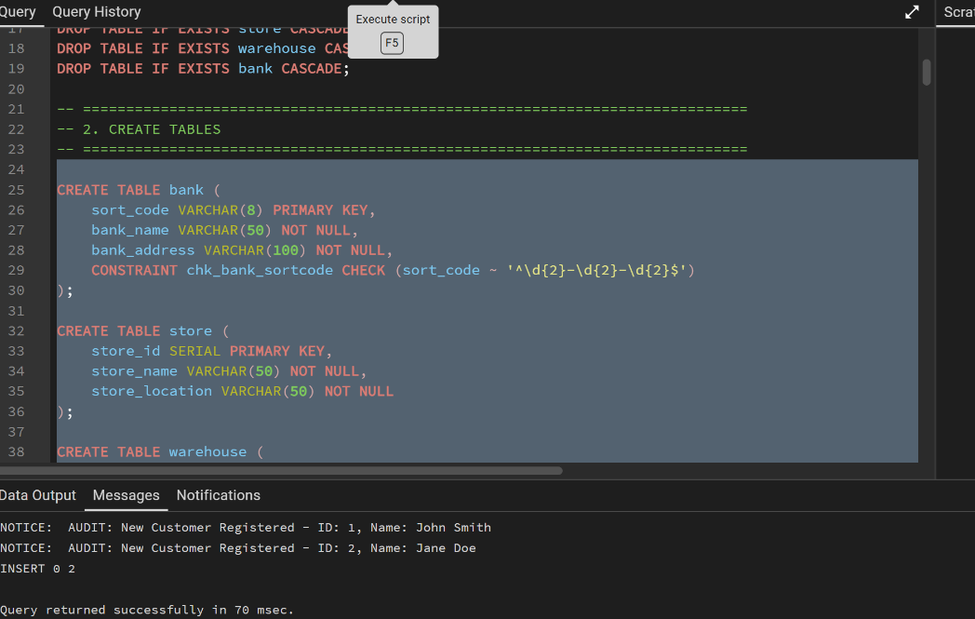
This shows my entire script executing perfectly. All tables, functions, and procedures were created without any syntax errors.

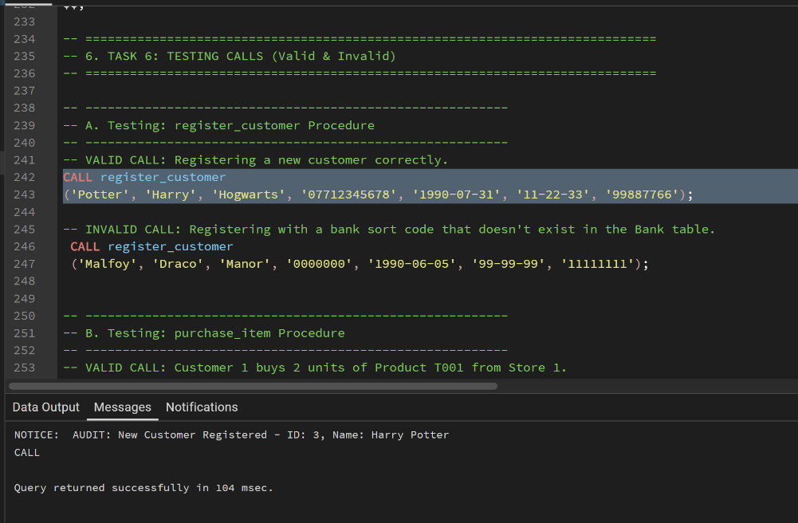
Testing a normal customer registration. You can also see my background Audit Trigger working because it automatically printed "AUDIT: New Customer Registered".
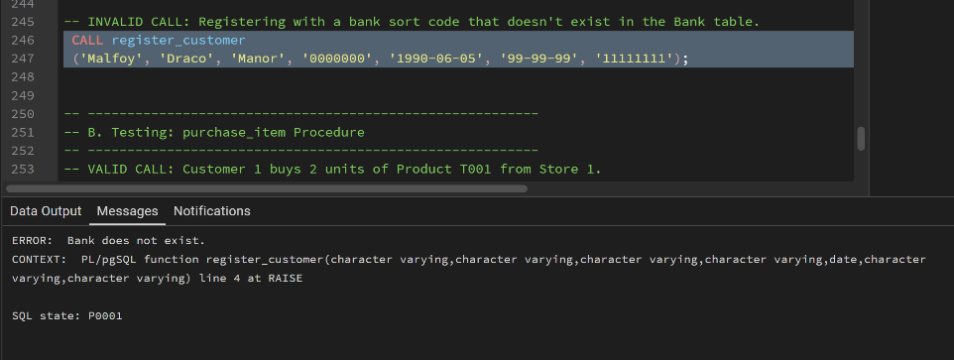
My attempt was to enroll a customer with a forged bank sort code. It was caught in the process and an error was thrown rather than bad data saved.

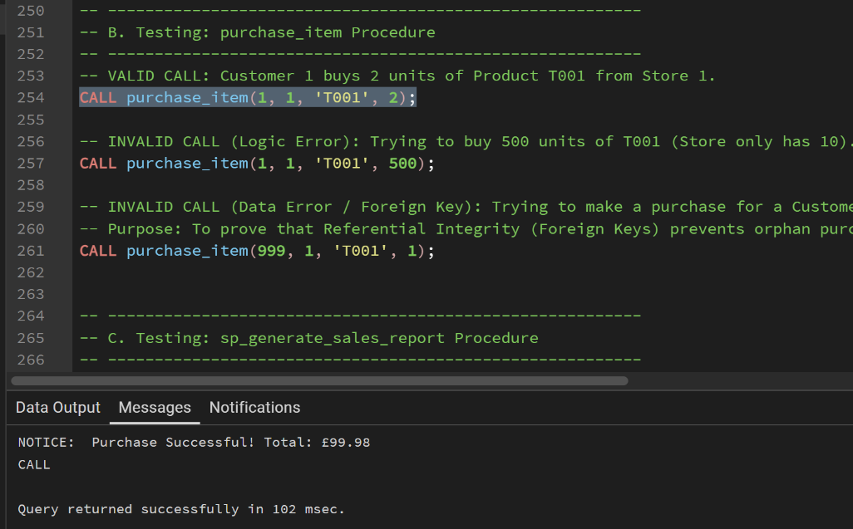
A standard purchase. The customer bought 2 items and the procedure correctly validate the total price and confirmed the sale.

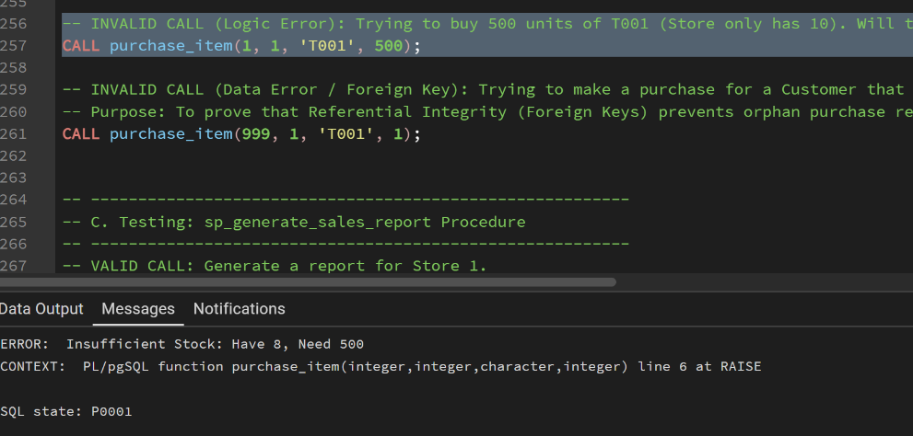
I attempted to purchase 500 toys and the store had 8 of them. My process was aware of the low stock level and stopped the deal to avoid negative inventory.
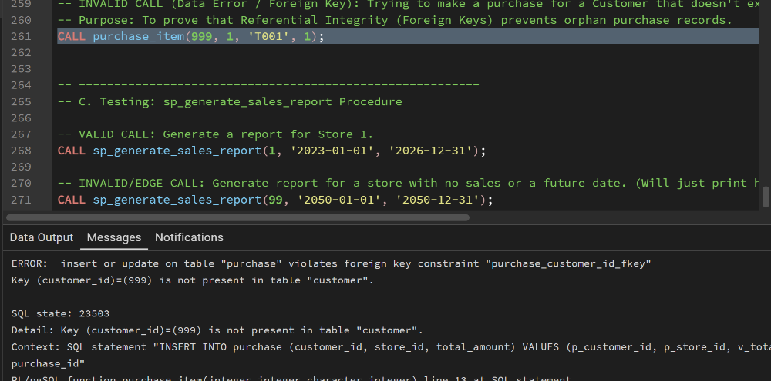
I attempted to record a purchase for Customer ID 999 who doesn't exist. The database's Foreign Key rules stepped in and blocked the insert to stop orphan records.

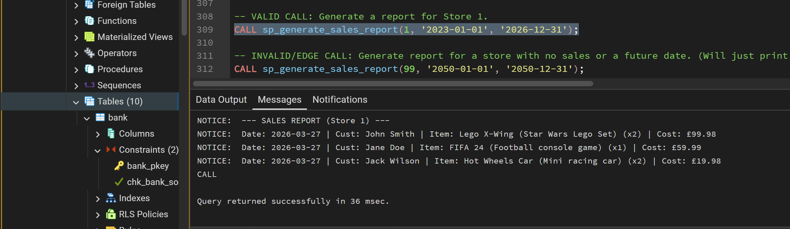
Operating the management report Store 1. The cursor was able to combine various tables to display who has purchased what and not just tabular ID numbers.
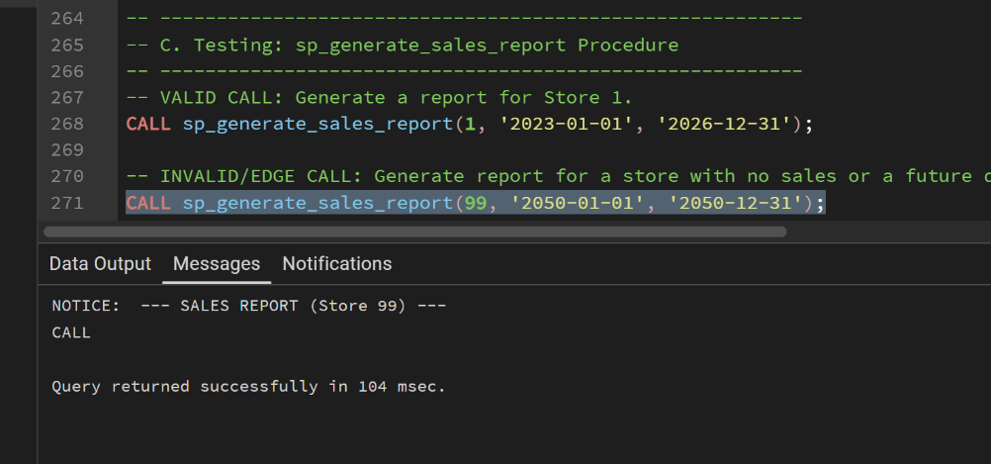
An edge case test: the report should be run with a year of 2050. The empty result set was handled gracefully by the procedure and it did not crash.

Error Checking and Validation in Stored Procedures
1. Procedure: The register_customer process is used to make sure that invalid data is not stored by using stringent validation checks. The bank sort_code format is checked against a regular expression to make sure that it is in the right format. It also confirms that the bank exists by asking the BANK table an IF NOT EXISTS query. In case the sort code is not located, a custom error is raised with the help of RAISE EXCEPTION that instantly halts the execution. This eliminates the possibility of wrong or false bank information being entered and referential integrity is upheld in the database.

2. Procedure: The purchase_item process makes sure that there is proper business logic and invalid transactions are avoided. It makes a helper call to get the existing stock level and then makes a purchase. When the quantity demanded is more than the stock, it will be halted by RAISE EXCEPTION to avoid negative inventory. The procedure also authenticates the product by ensuring that it exists by using IF NOT FOUND to retrieve the price of the product. In the case where the product is not available, the transaction is rolled back in a safe manner. These controls guarantee that only legitimate purchases are made and consistency of stock and transaction information.
3. Procedure: sp_generate_sales_report is a cursor that is used to navigate through joined tables to make sure that purchase, purchase_item, customer and product data is aggregated properly. The process maintains referential integrity by accessing valid foreign keys only and eliminates run time errors of invalid store IDs or date ranges. EXIT WHEN NOT FOUND makes sure if datasets are empty or non-existent datasets are handled gracefully and the transaction as well RAISE NOTICE is used to provide information without changing the state of the database. This will provide strong error management, data integrity and a clear audit trail and also enable the managers to produce detailed sales reports without any risk.

Part B

Security Management

User role testing summary
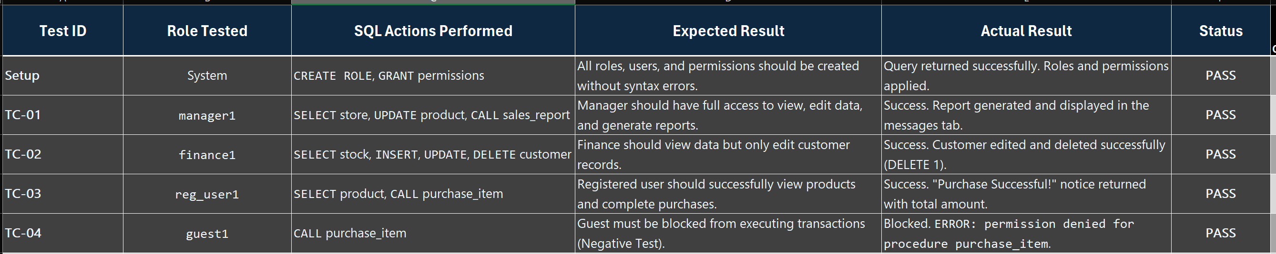
All security tests passed exactly as expected.

Screenshots Evidence
Setup
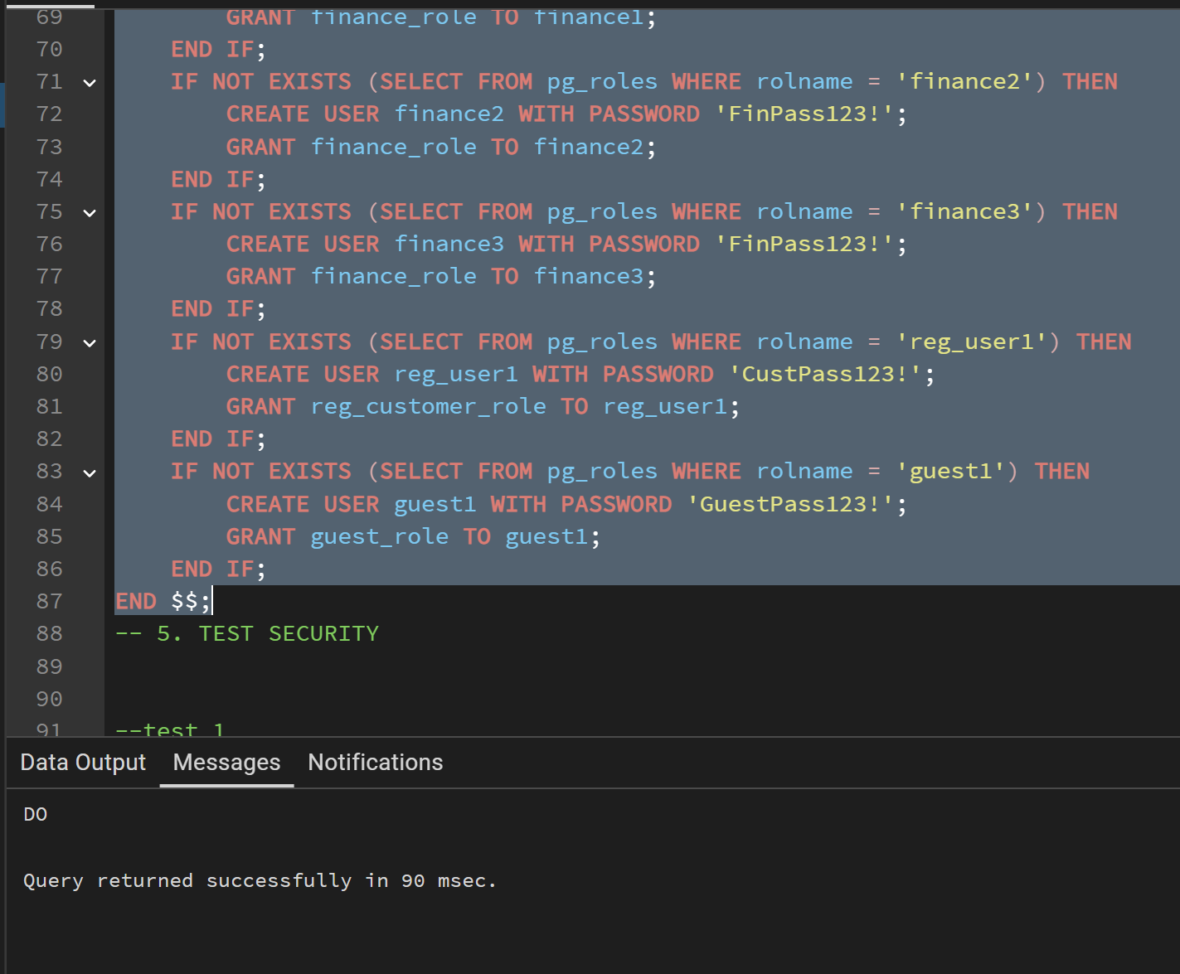
This is a screenshot that shows the successful implementation of the Role-Based Access Control (RBAC) set up script. It is confirmed that all database roles Manager, Finance, Registered Customer, Guest and individual users were created and given permissions successfully with no syntax or structural regulation errors as it was reflected by the message that the Query returned successfully.

TC-01
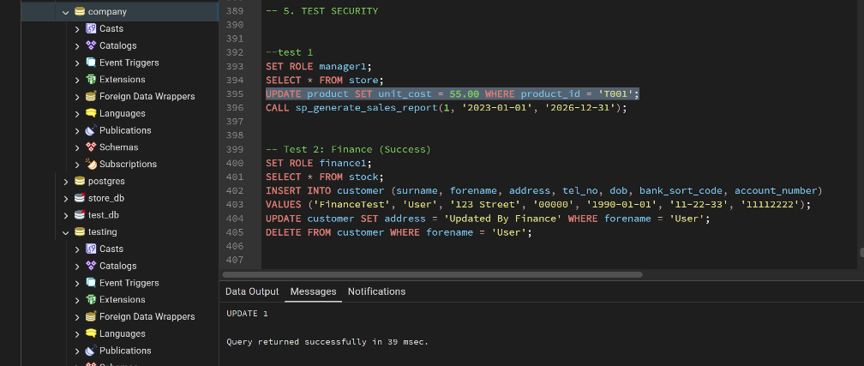
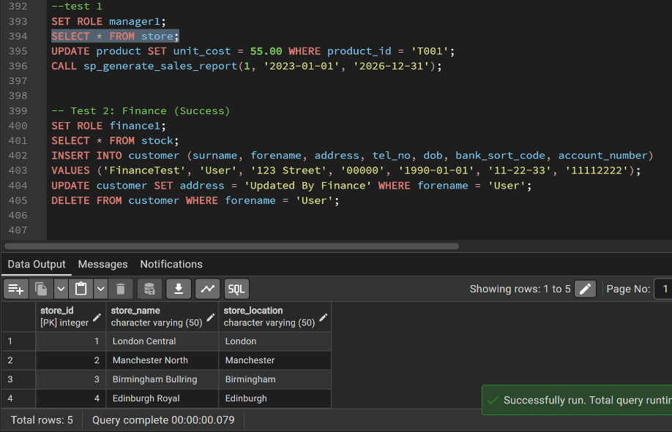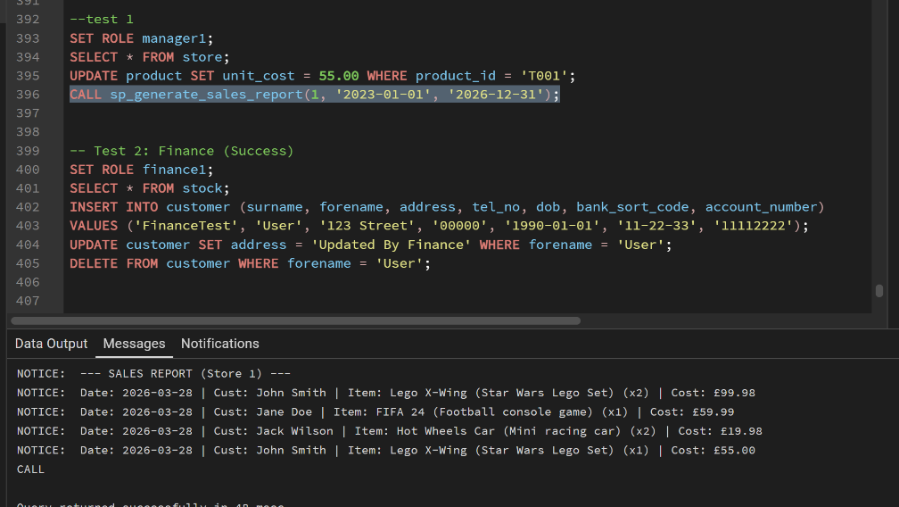
This screenshot confirm that Manager position manager1 is working just as demanded in the business scenario. It demonstrates the ability of the manager to perform administrative functions, such as product update records and calling the sp generate sales report procedure. The generated management report is well illustrated in the messages tab which demonstrates a complete administrative access.

TC-02
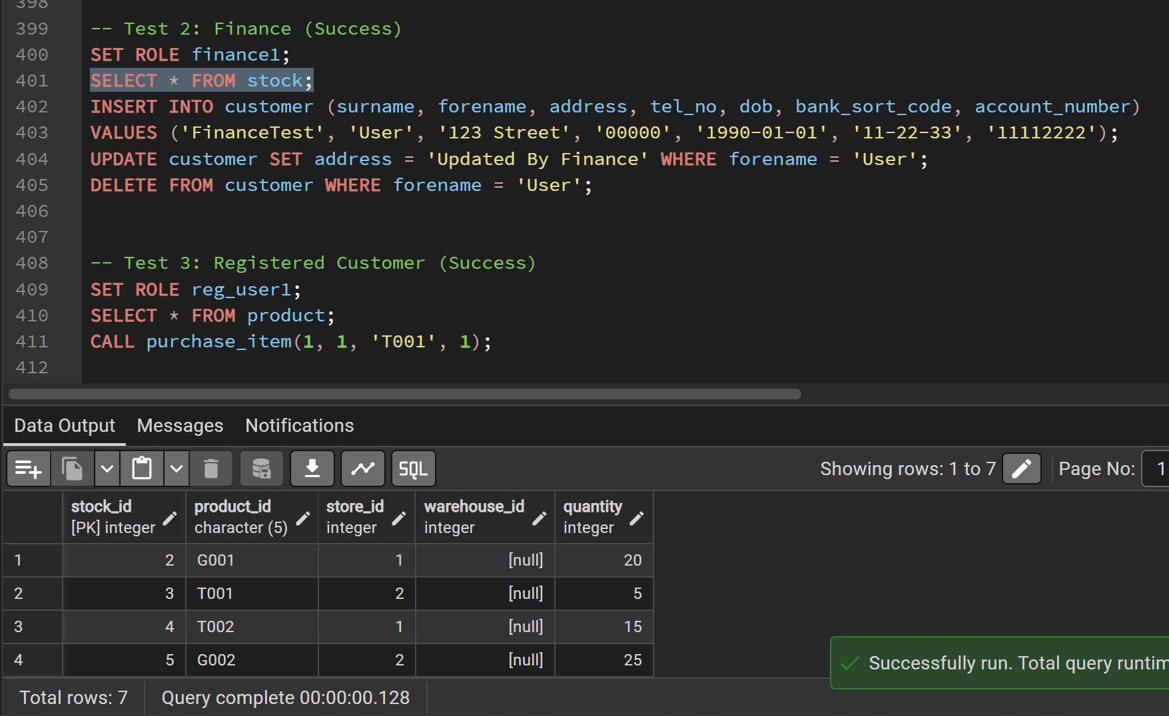
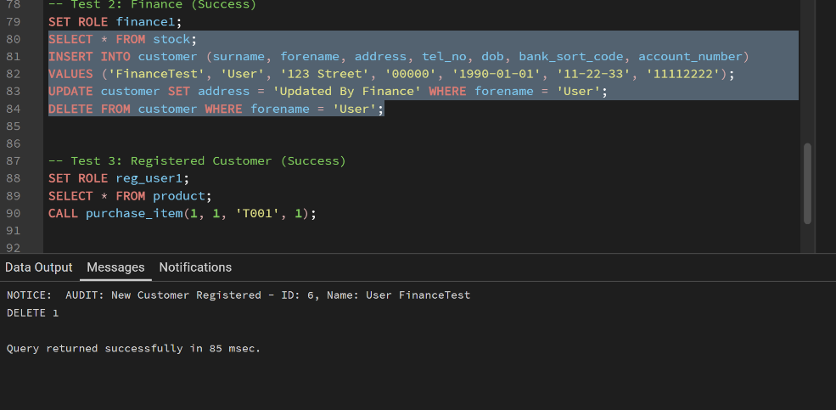
This screenshot symbolize the successful experimentation of the Finance staff job finance1. The finance user is able to process the entire information in customers at their convenience. The INSERT, UPDATE and DELETE statements are executed perfectly and this is verified in the results tab as the Audit trigger is activated sending the new customer and as the final message with the message of Delete 1 success.

TC-03
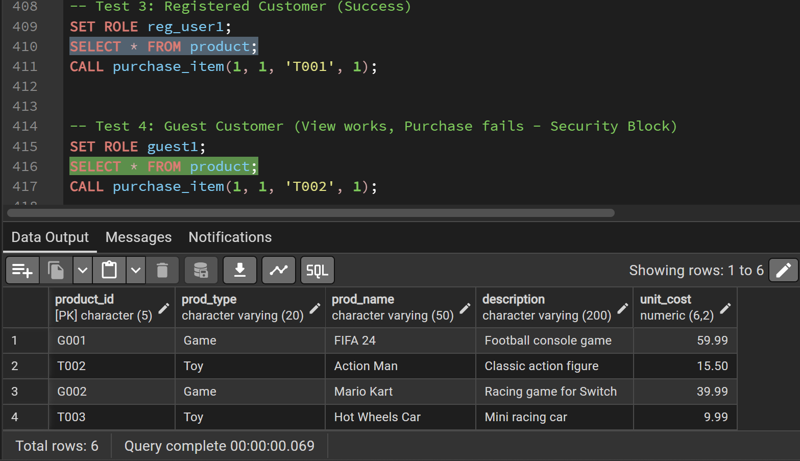
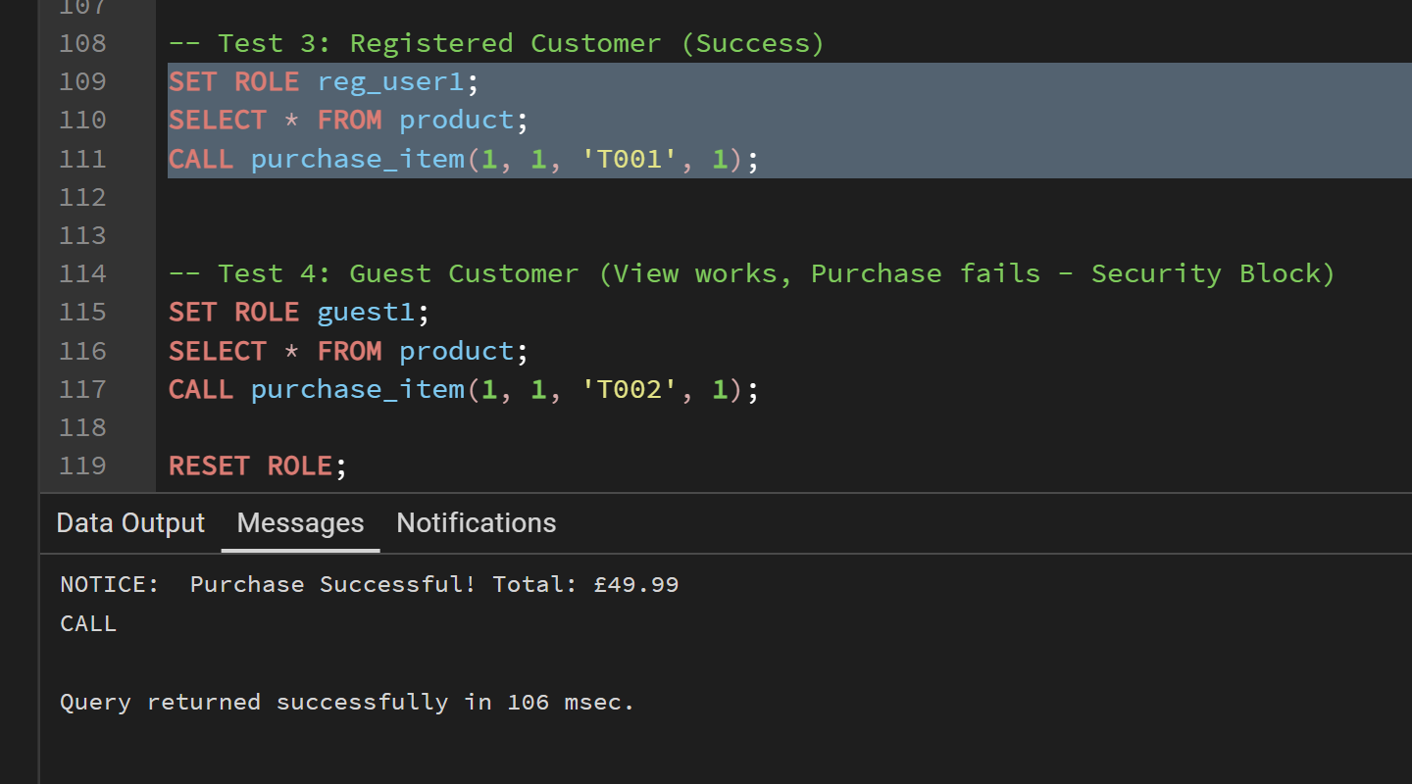
Here is his screen capture that shows that the Registered Customer has been able to make a transaction. The purchase item stored procedure is called by the user and database functions safely. On successful purchase is indicated in the output. note to the sum in question and it is shown that the designated position has the necessary permissions to purchase items without being blocked by the system.

TC-04
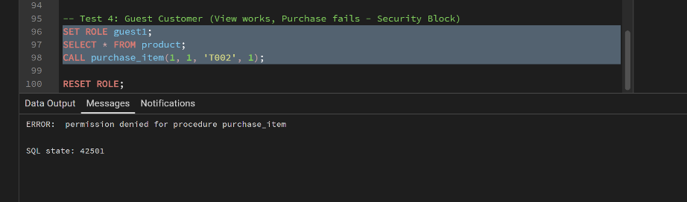
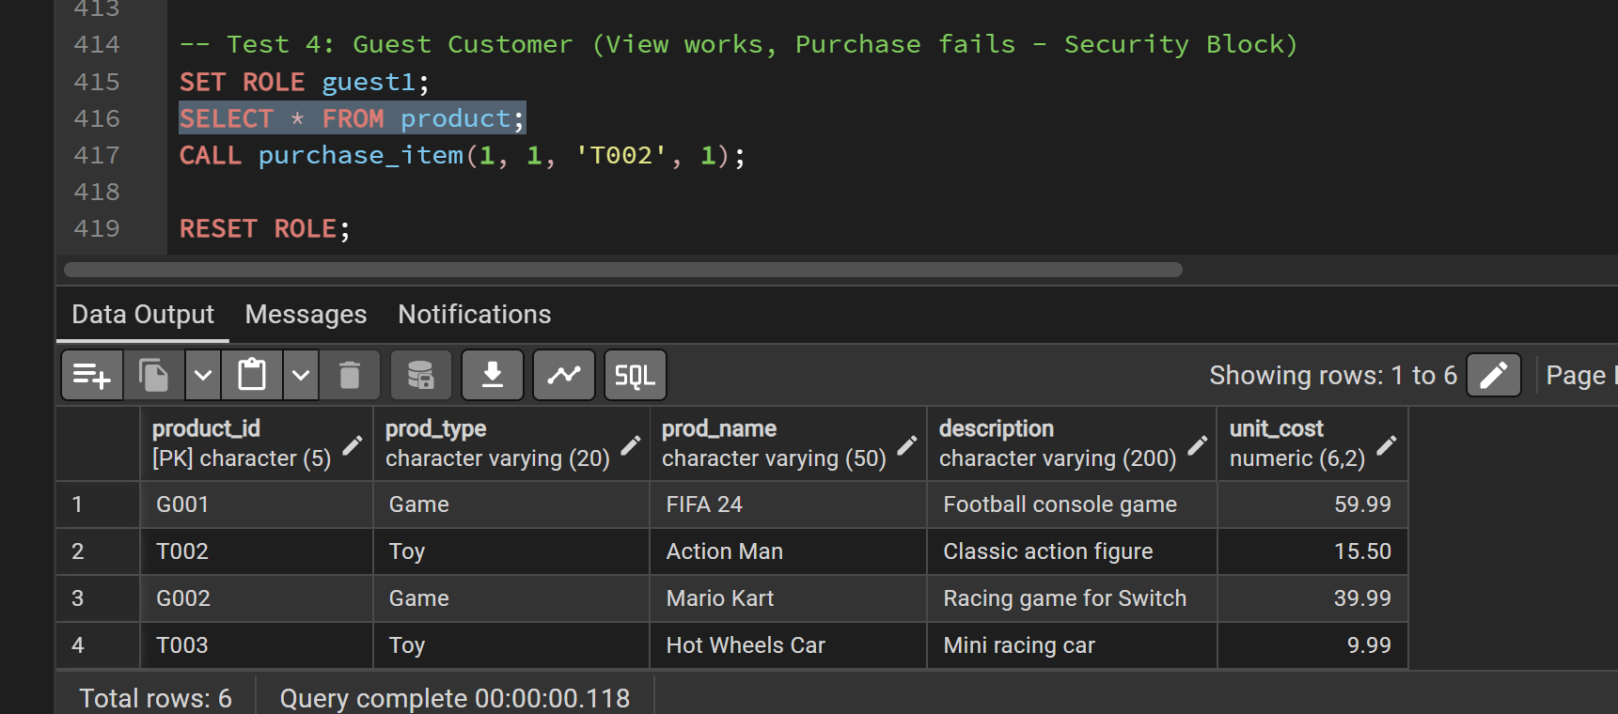
This screenshot is our evidence that the security system worked by denying unauthorized actions to be taken. When the Guest user attempts to make a purchase the database correctly makes a 'permission denied' error. This proves that unregistered users can only see products and cannot use the site to do such activities as buying an item.

Security Management Discussion
In this system, I applied Role-Based Access Control (RBAC) in PostgreSQL. It is inefficient to assign permissions to every user manually and (Sandhu et al., 1996) clarifies that RBAC is better in management as it assigns permissions to roles and not individuals. As per the scenario, I developed four roles: manager_role, finance_role, registered_customer_role, and guest_role.
The principle of least privilege was used to restrict access (Bertino and Sandhu, 2005). All data and reports are available to the manager, all data and updating customer records can be viewed by the finance staff, registered customers can make purchases and guests can read only the products.
To ensure that the PL/pgSQL procedures and functions were secured the default EXECUTE privileges of PUBLIC were revoked with the help of REVOKE EXECUTE ON ALL PROCEDURES IN SCHEMA public FROM PUBLIC and REVOKE EXECUTE ON ALL FUNCTIONS IN SCHEMA public FROM PUBLIC. This eliminates any unpermitted or automatic access to database routine.
DO block idea was also adopted to create the roles and users conditionally when they do not exist so that the script can be reused without causing the intuition of errors during execution. This enhances security and helps in standardizing security setup.
After this, authorizations were explicitly given by the least privilege principle. The helper functions like fn_get_stock_qty are limited to authorised roles to ensure that internal logic is not abused. GRANT EXECUTE ON PROCEDURE purchase to reg_customer role provides that only registered customers may perform purchase operations, but manager_role position can control all the procedures and functions.
In addition to this, access control was imposed on the guest role by removing the right to execute the purchase item procedure and making it not a member of reg_customer_role. Visitors can only do simple functions like accessing the product and registering through the register customer process. When a visitor tries to perform limited functions, an error of permission denied is displayed by the system which proves the role based access control (RBAC) to be enforced properly.
On the whole, this implementation guarantees enforcement to controlled access and securing sensitive operations together with raising database security levels by denying users access to anything but the operations pertinent to their roles.

References
Bertino, E. and Sandhu, R. (2005) “Database security - concepts, approaches, and challenges,” IEEE Transactions on Dependable and Secure Computing, 2(1), pp. 2–19. Available at: https://doi.org/10.1109/TDSC.2005.9.
Sandhu, R.S. et al. (1996) “Role-based access control models,” Computer, 29(2), pp. 38–47. Available at: https://doi.org/10.1109/2.485845.

